8.96: The trick here is to realize that the center of mass will continue to move in the original parabolic trajectory, “landing” at the position of the original range of the projectile. Since the explosion takes place at the highest point of the trajectory, and one fragment is given to have zero speed after the explosion, neither fragment has a vertical component of velocity immediately after the explosion, and the second fragment has twice the velocity the projectile had before the explosion. a) The fragments land at positions symmetric about the original target point. Since one lands at 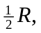 the other lands at
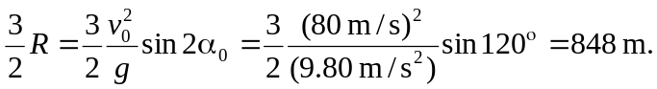

b) In terms of the mass of the original fragment and the speed before the explosion, 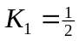 The speed is related to 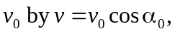so

